Photo save projet fin d’étude

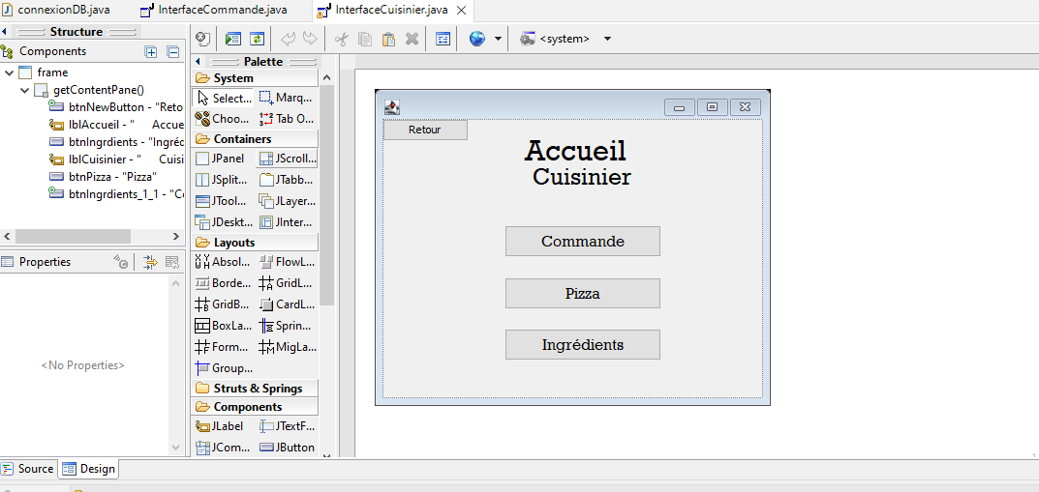

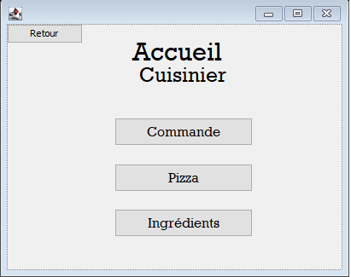

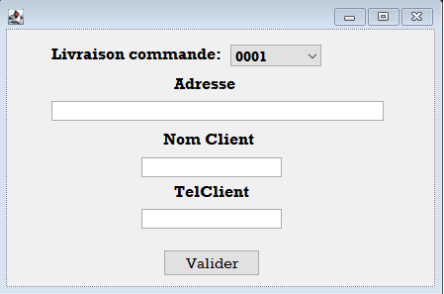

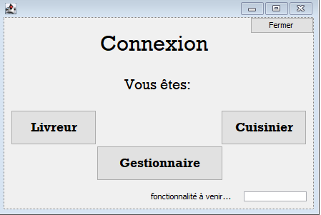

package packagePizza;

import java.awt.EventQueue;

import javax.swing.JFrame;

import javax.swing.JTextField;

import javax.swing.JLabel;

import javax.swing.SwingConstants;

import javax.swing.JButton;

import java.awt.event.ActionListener;

import java.awt.event.ActionEvent;

import javax.swing.BoxLayout;

import java.awt.BorderLayout;

import java.awt.Font;

import javax.swing.JPasswordField;

public class InterfacePizzeria {

public JFrame frame;

private JPasswordField passwordField;

/**

* Launch the application.

*/

public static void main(String[] args) {

EventQueue.invokeLater(new Runnable() {

public void run() {

try {

InterfacePizzeria window = new InterfacePizzeria();

window.frame.setVisible(true);

} catch (Exception e) {

e.printStackTrace();

}

}

});

}

/**

* Create the application.

*/

public InterfacePizzeria() {

initialize();

}

/**

* Initialize the contents of the frame.

*/

private void initialize() {

frame = new JFrame();

frame.setBounds(100, 100, 450, 308);

frame.setDefaultCloseOperation(JFrame.EXIT_ON_CLOSE);

frame.getContentPane().setLayout(null);

JLabel lblConnexion = new JLabel(" Connexion");

lblConnexion.setFont(new Font("Rockwell", Font.PLAIN, 30));

lblConnexion.setBounds(87, 0, 248, 72);

frame.getContentPane().add(lblConnexion);

JLabel lblVoustes = new JLabel(" Vous \u00EAtes:");

lblVoustes.setFont(new Font("Rockwell", Font.PLAIN, 20));

lblVoustes.setBounds(149, 70, 129, 49);

frame.getContentPane().add(lblVoustes);

JButton btnLivreur = new JButton("Livreur");

btnLivreur.addActionListener(new ActionListener() {

public void actionPerformed(ActionEvent e) {

InterfaceLivreur fenetreLivreur = new InterfaceLivreur();

fenetreLivreur.frame.setVisible(true);

frame.dispose();

}

});

btnLivreur.setFont(new Font("Rockwell", Font.BOLD, 18));

btnLivreur.setBounds(10, 130, 120, 49);

frame.getContentPane().add(btnLivreur);

JButton btnCuisinier = new JButton("Cuisinier");

btnCuisinier.addActionListener(new ActionListener() {

public void actionPerformed(ActionEvent e) {

InterfaceCuisinier newFenetreCuisinier = new InterfaceCuisinier();

newFenetreCuisinier.frame.setVisible(true);

frame.dispose();

}

});

btnCuisinier.setFont(new Font("Rockwell", Font.BOLD, 18));

btnCuisinier.setBounds(304, 130, 120, 49);

frame.getContentPane().add(btnCuisinier);

JButton btnGestionnaire = new JButton("Gestionnaire");

btnGestionnaire.addActionListener(new ActionListener() {

public void actionPerformed(ActionEvent e) {

InterfaceGestionnaire newFenetreGestion = new InterfaceGestionnaire();

newFenetreGestion.frame.setVisible(true);

frame.dispose();

}

});

btnGestionnaire.setFont(new Font("Rockwell", Font.BOLD, 18));

btnGestionnaire.setBounds(130, 180, 177, 49);

frame.getContentPane().add(btnGestionnaire);

passwordField = new JPasswordField();

passwordField.setBounds(336, 244, 88, 14);

frame.getContentPane().add(passwordField);

JLabel lblNewLabel = new JLabel("fonctionnalit\u00E9 \u00E0 venir...");

lblNewLabel.setBounds(206, 244, 129, 14);

frame.getContentPane().add(lblNewLabel);

JButton btnClose = new JButton("Fermer");

btnClose.addActionListener(new ActionListener() {

public void actionPerformed(ActionEvent e) {

frame.dispose();

}

});

btnClose.setBounds(345, 0, 89, 23);

frame.getContentPane().add(btnClose);

}

}

